# Programmable Embedded Systems (EE60098)

# Homework 5

Pratyush Jaiswal

18EE35014

In MATLAB Simulink: Take a signal generator and generate a square wave (high: +10V, low: -10V) of baud-rate 10,000, connect the wire (may be copper wire) to the signal generator and the other end of the wire to a CRO/DSO. Record the received waveforms in CRO/DSO.

**Circuit**

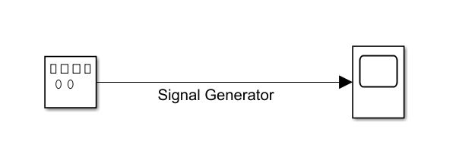

**Signal Generator Specification**

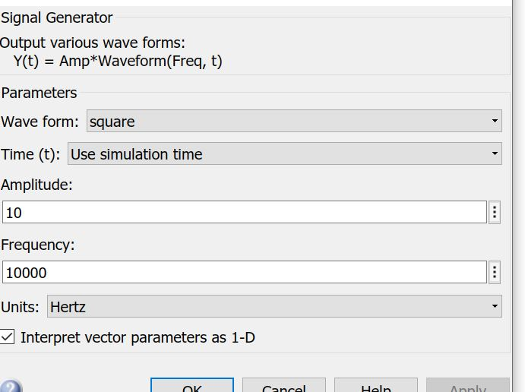

**Result**

